Project Report

on

# AppointHere

Submitted as a part of course curriculum for

**Bachelor of Technology**

in

## Computer Science



**Submitted by**

Shivam kumar (2000290120148)

Shivam dhaiya (2000290120147)

Tanishq vashishth (2000290120173)

**Under the Supervision of**

Prof. Rahul Kumar

**DEPARTMENT OF COMPUTER SCIENCE**

KIET GROUP OF INSTITIUTIONS GHAZIABAD

Affiliated to Dr. A.P.J. Abdul Kalam Technical University

2023-2024

## TABLE OF CONTENTS

|  |  |
| --- | --- |
| DECLARATION……………………………………………………………………. | i. |
| CERTIFICATE……………………………………………………………………… | ii. |
| ACKNOWLEDGEMENT…………………………………………………………. | iii. |
| ABSTRACT……………………………………………………………………….... | iv. |
| LIST OF FIGURES…………………………………………………………………. | v. |
| LIST OF TABLES…………………………………………………………………… | vi. |
| LIST OF ABBREVIATIONS………………………………………………………. | vii. |
| CHAPTER 1 INTRODUCTION  1.1 Introduction to Project  1.2 Project Category    CHAPTER 2 LITERATURE REVIEW  2.1 Literature Review  2.2 Problem Formulation  2.3 Objectives    CHAPTER 3 PROPOSED SYSTEM |  |

3.1 Proposed System

3.2 Unique Features of The System (Difference from Existing System) 3.3 Structure of Report

CHAPTER 4 (REQUIREMENT ANALYSIS AND SYSTEM SPECIFICATION)

4.1 Feasibility Study (Technical, Economical, Operational)

4.2 Software Requirement Specification Document Which Must Include the Following:

(Data Requirement, Functional Requirement, Performance Requirement,

Maintainability Requirement, Security Requirement)

4.3 SDLC Model to Be Used

4.3.1 System Design Using DFD Level 0 And Level 1

4.3.2 Use Case Diagram

4.3.3 Database Design

4.3.4 ER Diagram

CHAPTER 5 IMPLEMENTATION

5.1 Introduction to Languages, Tools and Technologies Used for Implementation.

CHAPTER 6 TESTING, AND MAINTENANCE

6.1 Testing Techniques and Test Cases Used

CHAPTER 7 (RESULTS AND DISCUSSIONS)

7.1 User Interface Representation (Of Respective Project)

7.2 Brief Description of Various Modules of The System

7.3 Snapshots of System with Brief Detail of Each

7.4 Back Ends Representation (Database to Be Used)

7.5 Snapshots of Database Tables with Brief Description

CHAPTER 8 CONCLUSION REFERENCES

CONCLUSION

REFERENCES (Only **in IEEE Style**)

## DECLARATION

We hereby declare that this submission is our work and that, to the best of our knowledge and belief, it contains no material previously published or written by another person nor material which to a substantial extent has been accepted for the award of any other degree or diploma of the university or other institute of higher learning, except where due acknowledgement has been made in the text.

Signature of Students

Name: Shivam kumar Shivam Dhaiya Tanishq vashishth

Roll No.: 2000290120148 2000290120147 2000290120173

Date:

## CERTIFICATE

This is to certify that Project Report entitled “**APPOINTHERE**” which is submitted by **SHIVAM KUMAR, SHIVAM DHAIYA, TANISHQ VASHISHTH** in partial Fulfilment of the requirement for the award of degree B. Tech. in Department of Computer Science of Dr A.P.J. Abdul Kalam Technical University, Lucknow is a record of the candidates own work carried out by them under my supervision. The matter embodied in this report is original and has not been submitted for the award of any other degree.

**Date: Supervisor**

**Signature**

Prof. Rahul Kumar

## ACKNOWLEDGEMENT

It gives us a great sense of pleasure to present the synopsis of the B.Tech Mini Project undertaken during B.Tech. Third Year. We owe a special debt of gratitude to Prof. Rahul kumar , Department of Computer Science, KIET Group of Institutions, Delhi- NCR, Ghaziabad, for her constant support and guidance throughout the course of our work. His sincerity, thoroughness and perseverance have been a constant source of inspiration for us. It is only his cognizant efforts that our endeavours have seen the light of the day.

We also take the opportunity to acknowledge the contribution of Dr. Ajay Kumar Shrivastava, Head of the Department of Computer Science, KIET Group of Institutions, Delhi- NCR, Ghaziabad, for his full support and assistance during the development of the project. We also do not like to miss the opportunity to acknowledge the contribution of all the faculty members of the department for their kind assistance and cooperation during the development of our project.

Last but not the least, we acknowledge our friends for their contribution to the completion of the project.

Signature:

Date :

Name : Shivam Kumar Shivma Dhaiya Tanishq Vashishth

Roll No: 2000290120148 2000290120147 2000290120173

## ABSTRACT

In today's fast-paced world, juggling professional commitments and family responsibilities can often become overwhelming. The constant demand for time and attention leaves little room for managing household maintenance and repairs. Yet, envisioning a life where such concerns are effortlessly addressed is not merely a dream but a tangible reality offered by the advent of E-Commerce.

To address this pressing need, we propose the development of a comprehensive platform designed to seamlessly connect users with a diverse range of essential services. From plumbing and repairs to cleaning and electrical work, our network offers a holistic solution to household maintenance woes.

The core of our platform lies in its simplicity and accessibility. Through a user-friendly mobile interface, individuals can effortlessly book services with just a few clicks. By uploading images detailing their requirements, users can initiate service requests, with our system efficiently managing the process from start to finish. Furthermore, our confirmation emails ensure peace of mind, providing reassurance that the requested services are in progress.

Whether at home or on the go, our platform empowers users to address their household needs from anywhere, at any time. With a commitment to streamlining life's everyday challenges, we aim to redefine the way individuals engage with essential home services, offering unparalleled convenience and peace of mind.

Keywords: E-Commerce, Household Services, Convenience, Simplification, Mobile-Friendly, Seamless Booking, Streamlining.

Here we can book services like painting house , carpenter ,electrician , cleaners and other

Services we will include in future .

## LIST OF FIGURE

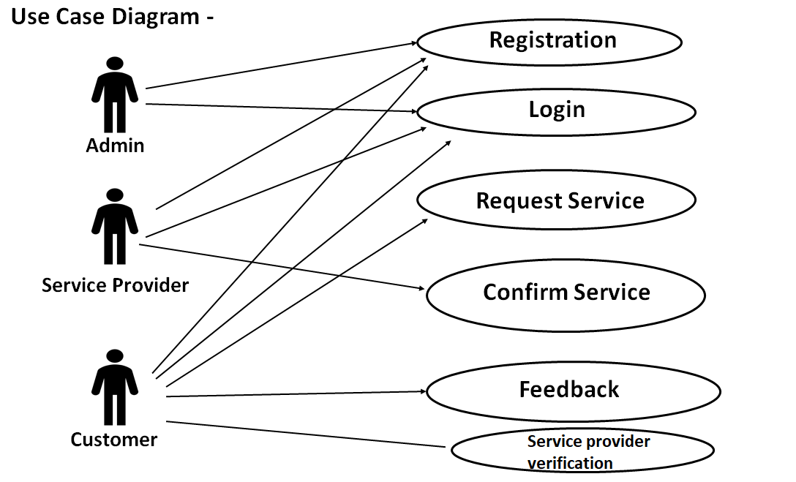

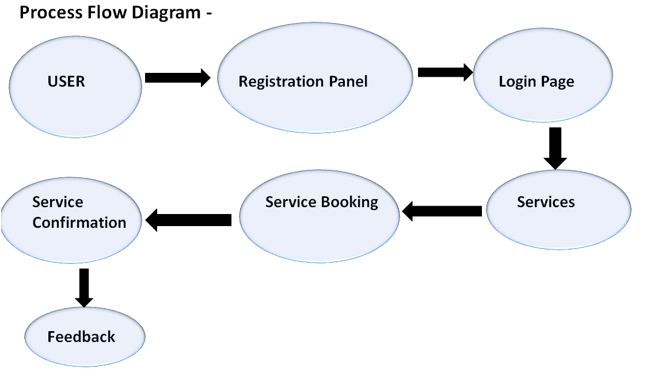

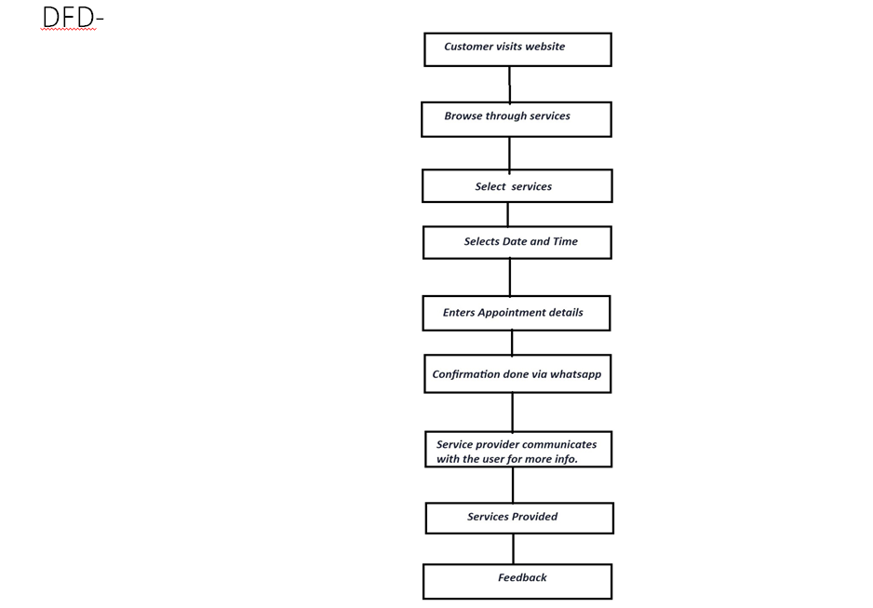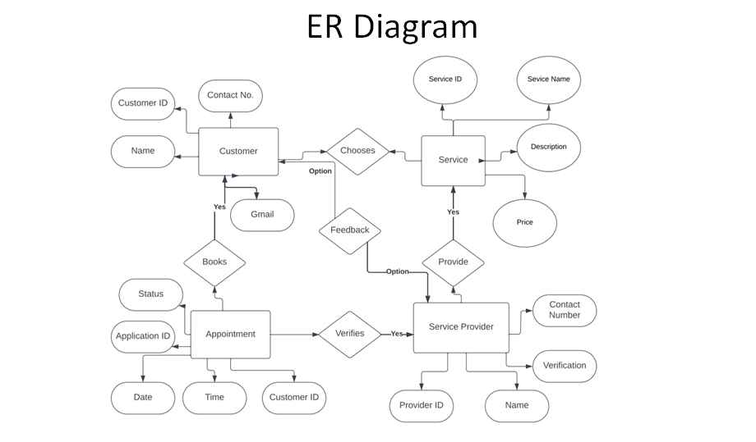

## CHAPTER 1: INTRODUCTION

### 1.1 INTRODUCTION

When faced with minor yet critical domestic duties, the challenge emerges when skilled service providers are unreachable or reliable options seem out of reach. Consistently impeccable service delivered promptly becomes a rarity. But fear not! Our online household services system offers the most prudent and hassle-free way to tackle domestic chores. Our mission? To offer perfect answers for each domestic issue with proficiency, simplicity and a fine sensitivity. Here’s how our system works:

1. Effortless Booking With a single click, you can book highly skilled in-house professionals. No more waiting or uncertainty—our system ensures timely service delivery.

2. Transparent Pricing Say goodbye to haggling over rates. Our marketplace standardizes prices, ensuring fairness for both customers and service providers. You pay for quality, and quality is what you receive.

3. Comprehensive Services Spanning from painting and vermin management to house sanitation, waterworks, circuitry tasks and woodcraft, we encompass everything. Our goal? To create a happy and healthy home atmosphere that satisfies consumers like you. Remember, a well-maintained home contributes to your overall well-being. Let us handle the details while you focus on what truly matters—your family and peace of mind

**1.2 PROJECT CATEGORY**

AppoinHere falls primarily under the category of "Technology and Innovation" with a focus on "Business and Entrepreneurship" and "Convenience and Efficiency." Here's why:

1. Technology and Innovation: AppoinHere utilizes technology to innovate the way household services are accessed and managed. By providing a digital platform for connecting users with local service providers, AppoinHere leverages technology to streamline the process of booking appointments and managing household tasks.

2. Business and Entrepreneurship: AppoinHere is a business venture aimed at addressing a specific market need – the demand for convenient and reliable household services. As an entrepreneurial endeavor, AppoinHere seeks to create value by offering a platform that connects service providers with customers in a mutually beneficial way.

3. Convenience and Efficiency: At its core, AppoinHere is all about providing convenience and efficiency to users. By offering a one-stop solution for booking a variety of household services with ease, AppoinHere simplifies the process of managing home maintenance tasks. Users can quickly find and book service providers, saving time and effort in the process.

In summary, AppoinHere combines elements of technology, entrepreneurship, and convenience to offer an innovative solution to the challenges of accessing household services. As a digital platform, it exemplifies the intersection of technology and business, demonstrating how innovation can enhance everyday experiences for individuals and communities.

**1.3 OBJECTIVES**

The primary objective of our online household services system is to bring home services directly to your abode with one click. In this paper , we investigate the central subject of digital home services, examine the extensive array of services provided, and consider the complexities of placing orders and the process of service provision. Our system caters to authorized users—service seekers, service providers, and administrators—via an ingenious web-based platform or a mobile application. Here are our key goals:

1. Authentication and Authorization We provide a secure login module where users can register with appropriate credentials. Whether you’re seeking services or providing them, our system ensures authorized access.

2. Web and Mobile Integration Our vision extends beyond the web. We’re developing both a web-based system and an identical mobile application for seamless service access. Convenience is our priority.

3. User-Friendly Interface An interactive User Interface (UI) ensures ease of use. Whether you’re at home or on the move, seeking services becomes effortless.

4. Secure Payment Gateway We’ve implemented a robust online payment gateway for service seekers. Your transactions are safe and hassle-free.

5. Service Confirmation Users receive acknowledgment for the services they’ve opted for. No more uncertainty—our system keeps you informed.

6. Quality Assurance Our commitment to excellence extends beyond convenience. We rigorously vet our service providers, ensuring that only skilled professionals with a track record of reliability join our network. Your satisfaction is our priority.

**1.4 PROBLEM FORMULATION**

1. Supply and Demand Imbalance: Balancing the number of service providers with the demand for their services can be a challenge. Ensuring that there are enough providers available to meet user needs without overwhelming them or leaving them waiting for service is crucial.

2. Quality Control: Maintaining consistent quality across various service providers can be difficult. Ensuring that all providers meet certain standards of professionalism, skill, and reliability is essential to maintaining customer satisfaction.

3. Trust and Safety: Building trust between users and service providers is paramount. Implementing measures to verify the identity and credibility of service providers, as well as providing safety assurances for users, is critical to the success of the platform.

4. User Experience: Creating a seamless and intuitive user experience is essential for the success of your platform. Ensuring that users can easily navigate the platform, book services, and communicate with providers will be key to driving user adoption and retention.

5. Technical Challenges: Developing and maintaining the technological infrastructure required to support the platform can present numerous challenges. This may include issues related to scalability, security, and system integration.

6. Market Competition: In a crowded marketplace, standing out from competitors can be a challenge. Understanding your unique value proposition and finding ways to differentiate your platform from others will be crucial to attracting and retaining users.

7. Regulatory Compliance: Ensuring compliance with relevant regulations and legal requirements, such as labor laws, privacy regulations, and consumer protection laws, is essential to avoiding legal issues and maintaining the trust of users.

8. Revenue Model: Developing a sustainable revenue model that balances the needs of both users and service providers can be challenging. Exploring different monetization strategies, such as subscription fees, transaction fees, or premium features, will be important to the long-

**CHAPTER 2: LITERATURE RIVIEW**

**2.1 LITERATURE RIVIEW**

For a project like AppoinHere, the literature review would involve exploring existing research, studies, and industry reports related to several key areas:

1. Household Service Industry: Reviewing literature on the household service industry can provide insights into market trends, consumer behavior, and challenges faced by both service providers and customers. Understanding the dynamics of the industry can help identify opportunities for innovation and improvement.

2. E-Commerce and Online Marketplaces: Examining literature on e-commerce and online marketplaces can shed light on best practices for platform development, user experience design, and business models. Insights from successful e-commerce platforms can inform the design and implementation of features for AppoinHere.

3. User Behavior and Preferences: Researching literature on user behavior and preferences in the context of online service booking can provide valuable insights into user expectations, motivations, and pain points. Understanding user needs and preferences can guide the design of AppoinHere's interface and features.

4. Technology Adoption and Digital Transformation: Exploring literature on technology adoption and digital transformation in various industries can provide insights into the factors influencing the adoption of digital platforms for service booking. Understanding the drivers and barriers to adoption can inform strategies for marketing and user acquisition.

5. Trust and Reputation Management: Reviewing literature on trust and reputation management in online platforms can provide insights into strategies for building and maintaining trust between users and service providers. Understanding the factors that influence trust and reputation can inform policies and mechanisms for ensuring reliability and accountability on AppoinHere.

6. Mobile Application Development: Examining literature on mobile application development can provide insights into best practices for designing and developing mobile-friendly interfaces and optimizing performance for different devices and platforms. Insights from mobile app development can inform the design and implementation of AppoinHere's mobile application.

7. Regulatory and Legal Considerations: Researching literature on regulatory and legal considerations in the context of online service marketplaces can provide insights into compliance requirements, liability issues, and risk management strategies. Understanding the legal landscape can inform the development of policies and terms of service for AppoinHere.

By conducting a comprehensive literature review across these key areas, you can gain valuable insights and knowledge that will inform the development and implementation of AppoinHere, ensuring that the platform meets the needs and expectations of both users and service providers.

|  |
| --- |
|  |
|  |
|  |
| **CHAPTER 3: PROPOSED SYSTEM**  **3.1 PROPOSED SYSTEM**  The proposed system of AppoinHere aims to revolutionize the way household services are accessed and managed. Through a user-friendly and intuitive platform, users will have seamless access to a diverse range of essential services, including plumbing, electrical work, cleaning, repairs, and more. The system will prioritize convenience, efficiency, and reliability, allowing users to easily browse service providers, book appointments, and track the progress of their requests. Service providers, in turn, will benefit from increased visibility, streamlined appointment management, and access to a broader customer base. With features such as real-time scheduling, transparent pricing, and user ratings, the proposed system of AppoinHere will enhance the overall experience of accessing household services, making it simpler, faster, and more convenient for both users and service providers alike.  **3.2 UNIQUE FEATURES OF SYSTEM**  So our system provides a platform where all costumers can interact with local household service providers and take their help for there work and make their life easier , all work done by only filling one google form . here we can book appointment by only filling one google form , and some other features and upcoming features are –  The unique features of the AppoinHere system set it apart from traditional methods of accessing household services and other similar platforms. Here are some key unique features:  1. Image-Based Booking: AppoinHere allows users to upload images specifying their service requirements. This innovative feature simplifies the booking process and ensures accurate service provision by providing visual context to service providers.  2. Real-Time Scheduling: The platform offers real-time scheduling capabilities, allowing users to book appointments based on service provider availability. This feature enhances convenience and flexibility by enabling users to find suitable time slots that align with their schedules.  3. Mobile-Friendly Environment: AppoinHere is optimized for mobile devices, offering a seamless and user-friendly experience on smartphones and tablets. This mobile-friendly environment enables users to access the platform anytime, anywhere, enhancing accessibility and convenience.  4. Confirmation Emails: After booking a service, users receive confirmation emails providing details of their selected services. This feature enhances transparency and provides users with reassurance that their service requests have been successfully processed.  5. Versatile Booking: Whether users are at home or on the go, AppoinHere allows for versatile booking from anywhere to everywhere. This flexibility enables users to manage their household service needs efficiently, regardless of their location.  6. Service Variety: The platform offers a wide spectrum of services, including plumbing, electrical work, cleaning, repairs, and more. This diverse range of services caters to various household needs, ensuring that users can find the right professionals for their specific requirements.  7. Verified Service Providers: AppoinHere implements stringent verification procedures for service providers, ensuring that only reputable and reliable professionals are listed on the platform. This commitment to quality and trustworthiness enhances user confidence and satisfaction.  8. Transparent Pricing: Users can view transparent pricing information for different services, helping them make informed decisions based on their budget and preferences. This transparency fosters trust and eliminates uncertainty in the service booking process.  9. Rating and Review System: AppoinHere features a rating and review system where users can provide feedback on their service experiences. This system promotes accountability and encourages service providers to maintain high standards of performance and customer satisfaction.  10. Community Engagement: The platform fosters community engagement by connecting users with local service providers in their area. This localized approach promotes support for local businesses and strengthens community ties.  These unique features distinguish AppoinHere as a leading platform for accessing household services, offering unparalleled convenience, reliability, and user satisfaction. |
| **CHAPTER 4: REQUIREMENT ANALYSIS AND SYSTEM SPECIFICATION**  **4.1: Feasibility Study:** A Feasibility Study is a preliminary study undertaken before the real work of a project starts to ascertain the likely hood of the projects success. It is an analysis of possible alternative solutions to a problem and a recommendation on the best alternative. Economic Feasibility Technical Feasibility Operational Feasibility Economic Feasibility It is defined as the process of assessing the benefits and costs associated with the development of project. A proposed system, which is both operationally and technically feasible, must be a good investment for the organization. With the proposed system the users are greatly benefited as the users can be able to detect the fakeness from the real news and are aware of most real and most fake news published in the recent years. This proposed system does not need any additional software and high system configuration. Hence the proposed system is economically feasible.   * **Technical Feasibility:** The technical feasibility in the proposed system deals with the technology used in the system. It deals with the hardware and software used in the system whether they are of latest technology or not. It happens that after a system is prepared a new technology arises and the user wants the system based on that technology. Technical Feasibility The technical feasibility infers whether the proposed system can be developed considering the technical issues like availability of the necessary technology, technical capacity, adequate response and extensibility. The project is decided to build using Python. Jupiter Note Book is designed for use in distributed environment of the internet and for the professional programmer it is easy to learn and use effectively. As the developing organization has all the resources available to build the system therefore the proposed system is technically feasible. * **Economical Feasibility:** Economic analysis is the most frequently used method for evaluating theeffectiveness of a new system. More commonly known as cost/benefit analysis. * **Operational Feasibility:** The project has been developed in such a way that it becomes very easy even for a person with little computer knowledge to operate it. This software is very user friendly and does require any technical person to operate. Thus, the project is even operationally feasible. . Operational feasibility is defined as the process of assessing the degree to which a proposed system solves business problems or takes advantage of business opportunities.   **4.2: SOFTWARE REQUIREMENT SPECIFICATION** |
| **Hardware Requirement:**   1. CPU: Intel Core i5 or higher. 2. RAM: 8GB or higher. 3. Storage: 256GB SSD or higher. 4. Network Interface: Ethernet or Wi-Fi. 5. Display: 1080p or higher.   **Software Requirement:**   1. Operating System: Windows 10 or higher. 2. Node.js: version 14.0.0 or higher. 3. MongoDB: version 4.0.0 or higher. 4. Visual Studio Code: version 1.56.0 or higher. 5. NPM: version 7.0.0 or higher.   **Communication Requirement:**   1. Ethernet: The system will use Ethernet for communication between the client and server. 2. Wi-Fi: The system will use Wi-Fi for communication between the client and server. 3. Remote Desktop Protocol (RDP): The system will use RDP for remote access and control of computers. 4. Secure Socket Layer (SSL): The system will use SSL for secure data transmission between the client and server. 5. Transmission Control Protocol/Internet Protocol (TCP/IP): The system will use TCP/IP for communication between the client and server. |
|  |
| **Functional requirements:**   1. File Monitoring: The system should be able to monitor all file access and usage on the system, including file opening, modification, and deletion. 2. Security Features: The system should have the ability to detect and alert the user of any suspicious activity, including file access from unknown sources, modifications to critical system files, and attempts to access restricted files. 3. Remote Mouse and Keyboard Control: The system should have the ability to control the mouse and keyboard of remote computers, allowing for remote access and troubleshooting. 4. RDP Functionality: The system should be built using JavaScript and Node.js, enabling easy integration with other systems and the ability to extend to RDP functionality. 5. User Management: The system should allow for the creation and management of user accounts with varying levels of access and permissions. 6. Reporting: The system should have the ability to generate detailed reports on file access and usage, security events, and remote access activity.               **Non-functional requirements:**   1. Performance: The system should be able to handle high volumes of file access and usage with minimal impact on system performance. 2. Security: The system should be designed with security in mind, including secure data transmission, encryption, and secure user authentication. 3. Usability: The system should be user-friendly, with a simple and intuitive interface. 4. Reliability: The system should be reliable and available at all times, with minimal downtime and maintenance. 5. Scalability: The system should be designed to handle a growing number of users and systems. 6. Compatibility: The system should be compatible with a wide range of operating systems, file types, and network configurations. |

**4.3 SDLC MODEL TO BE USED**

**Structured Phases:** The Waterfall model follows a clear and sequential structure, with defined phases for requirements, design, implementation, testing, deployment, and maintenance. This structured approach aligns well with projects that have well-defined and stable requirements.

**Thorough Planning Emphasis:** Waterfall places a strong emphasis on meticulous planning and extensive documentation in the initial stages. This proves critical for your project, where a comprehensive understanding of vital components such as the chat dashboard, user authentication, and location tracking features is imperative.

**Detailed Requirements Management:** The Waterfall model excels when requirements are firmly established and less likely to undergo significant alterations throughout the project lifecycle. For functionalities like the intrusion tracking in our case, detailed specifications that undergo infrequent revisions are pivotal.

**Systematic Testing Approach:** Waterfall's phased approach allows for structured testing after the development phase concludes. This is particularly beneficial for your project, ensuring that individual components like user authentication undergo rigorous testing before progressing to subsequent phases (operational network intrusion system).

### 3.3 STRUCTURE OF THE REPORT

Chapter 1: Introduction

1.1 Introduction to Project

1.2 Project Category

Chapter 2: Literature Review

2.1 Literature Review

2.2 Problem Formulation

2.3 Objectives

Chapter 3: Proposed System

3.1 Proposed System

3.2 Unique Features of The System

4.3 Structure of Report (This section)

Chapter 4: Requirement Analysis and System Specification

4.1 Feasibility Study (Technical, Economical, Operational)

4.2 Software Requirement Specification Document

4.3 SDLC Model to Be Used

4.3.1 System Design Using DFD Level 0 And Level 1

4.3.2 Use Case Diagram

4.3.3 Database Design

4.3.4 ER Diagram

Chapter 5: Implementation

Chapter 6: Testing and Maintenance

Chapter 7: Results and Discussions

7.1 User Interface Representation (Of Respective Project)

7.2 Brief Description of Various Modules of The System

7.3 Snapshots of System with Brief Detail of Each

7.4 Back Ends Representation (Database to Be Used)

7.5 Snapshots of Database Tables with Brief Description

Chapter 8: Conclusion and Future Scope

References

.  **SYSTEM ` DESIGN**

**4.4: DETAIL DESIGN**

Software design sits at the technical kernel of the software engineering process and is applied regardless of the development paradigm and area of application. Design is the first step in the development phase for any engineered product or system. The designer’s goal is to produce a model or representation of an entity that will later be built. Beginning, once systemrequirement have been specified and analyzed, system design is the first of the three technical activities design, code and test that is required to build and verify software. The importance can be stated with a single word “Quality”. Design is the place where quality is fostered in software development. Design provides us with representations of software that can assess quality. Design is the only way that we can accurately translate a customer’s view into a finished software product or system. Software design serves as a foundation for all the software engineering steps that follow. Without a strong design we risk building an unstable system – one that will be difficult to test, one whose quality cannot be assessed until the last stage. The purpose of the design phase is to plan a solution of the problem specified by the requirement document. This phase is the first step in moving from the problem domain to the solution domain. In other words, starting with what is needed; design takes us toward how to satisfy the needs. The design of a system is perhaps the most critical factor affection the quality of the software; it has a major impact on the later phase, particularly testing, maintenance. The output of this phase is the design document. This document is similar to a blueprint for the solution and is used later during implementation, testing and maintenance. The design activity is often divided into two separate phases System Design and Detailed Design. System Design also called top-level design aims to identify the modules that should be in the system, the specifications of these modules, and how they interact with each other to produce the desired results. At the end of the system design all the major data structures, file formats, output formats, and the major modules in the system and their specifications are decided. During, Detailed Design, the internal logic of each of the modules specified in system design is decided. During this phase, the details of the data of a module are usually specified in a highlevel design description language, which is independent of the target language in which the software will eventually be implemented. In system design the focus is on identifying the modules, whereas during detailed design the focus is on designing the logic for each of the modules. In other works, in system design the attention is on what components are needed, while in detailed design how the components can be implemented in software is the issue. Design is concerned with identifying software components specifying relationships among components. Specifying software structure and providing blue print for the document phase. Modularity is one of the desirable properties of large systems. It implies that the system is divided into several parts. In such a manner, the interaction between parts is minimal clearly specified. During the system design activities, Developers bridge the gap between the requirements specification, produced during requirements elicitation and analysis, and the system that is delivered to the user. Design is the place where the quality is fostered in development. Software design is a process through which requirements are translated into a representation of software

**4.5 SYSTEM DESIGN USING DFD LEVEL 0 AND LEVEL 1**

### 4.6. SOFTWARE REQUIREMENT SPECIFICATION DOCUMENT

The Software Requirement Specification (SRS) document outlines the functional and nonfunctional requirements of the proposed system. It includes the following components:

1. Data Requirement:

Specification of data sources, formats, and quality requirements.

Identification of data preprocessing steps, including cleaning, normalization, and feature extraction.

Description of data storage and retrieval mechanisms, including database schemas.

1. Functional Requirement:

Description of system functionality, including user interactions, data processing workflows.

Specification of functional modules, their inputs, outputs, and interdependencies.

Use case scenarios and diagrams illustrating system behavior under various conditions.

1. Performance Requirement:

Definition of performance metrics, including accuracy, latency, throughput, and scalability.

Specification of performance targets and benchmarks against which the system will be evaluated.

Identification of performance optimization strategies, such as parallel processing and caching.

1. Maintainability Requirement:

Description of system architecture, design principles, and coding standards to facilitate maintenance.

Documentation of software components, APIs, and interfaces for ease of understanding and modification.

Implementation of version control, bug tracking, and testing frameworks to support ongoing maintenance activities.

1. Security Requirement:

Identification of security threats and vulnerabilities associated with the system, including data breaches, unauthorized access, and data integrity risks.

Specification of security controls, such as authentication, encryption, and access control mechanisms.

Compliance with relevant data protection regulations and industry standards to ensure the confidentiality and integrity of sensitive information.

## CHAPTER 5: IMPLEMENTATION

**5.1 INTRODUCTION TO LANGUAGES, TOOLS AND TECHNOLOGIES USED**

### FOR IMPLEMENTATION

1. Project Management and Collaboration:

- Slack or Microsoft Teams for team communication and collaboration.

- Google Workspace or Microsoft Office 365 for document sharing and collaboration.

2. Design:

- Adobe XD, Sketch, or Figma for UI/UX design and prototyping.

- Adobe Photoshop or Illustrator for graphic design and asset creation.

- InVision or Marvel for creating interactive prototypes and wireframes.

- Used canvas for frontend designing .

3. Frontend Development:

- HTML, CSS, JavaScript for building the frontend.

- Frontend frameworks/libraries like React.js, Vue.js, or Angular for building dynamic and interactive user interfaces.

- Code editors like Visual Studio Code, Sublime Text, or Atom for writing code.

- Version control systems like Git and hosting platforms like GitHub or GitLab for code collaboration and version control.

4. Backend Development:

- use free and open sources present on internet such as pabbly connect and gmail IMAP /POP

5. Database Management:

- used google sheet of google forms as database

6. API Integration:

- use open source applications to build free app

## CHAPTER 6: TESTING AND MAINTENANCE

### 6.1 TESTING TECHNIQUES AND TEST CASES USED

1. Unit Testing:

Test Case: Test each function or method individually to ensure they produce the expected output for a given input. For example, test the data preprocessing functions to verify that they handle missing values, outliers, and feature scaling correctly.

1. Integration Testing:

Test Case: Verify the interactions between different components of the system, such as data preprocessing, feature engineering, model training, and prediction. For instance, test the integration between the data loading module and the feature selection module to confirm that selected features are passed correctly to the model.

1. Regression Testing:

Test Case: Repeatedly test the system after making changes or updates to ensure that new modifications do not introduce regressions or unintended side effects. For example, after updating the model architecture or hyperparameters, re-run validation tests to confirm that the model's performance has not deteriorated.

1. Performance Testing:

Test Case: Assess the system's performance under different conditions, such as varying dataset sizes or computational resources. Measure metrics like training time, inference time, and memory usage to identify potential bottlenecks and optimize the system for efficiency.

Testing :-

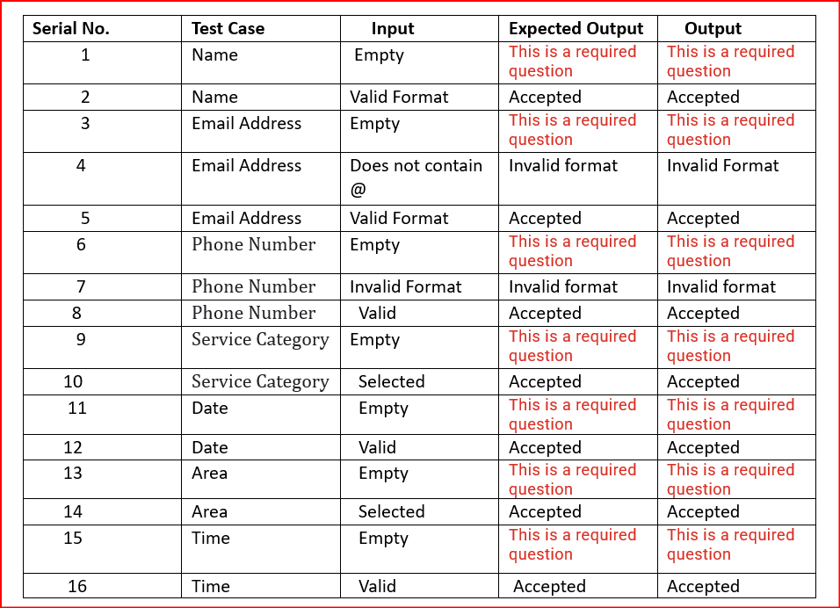

Table 2 :-

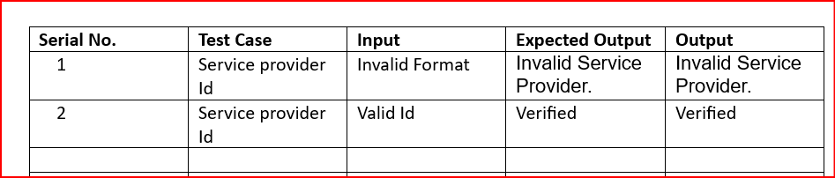

### CHAPTER 7.RESULTS AND DISSCUSSIONS

Your website, AppoinHere, will yield several results and benefits for both users and service providers:

1. Convenience: Users will enjoy the convenience of accessing a wide range of household services from a single platform. They can easily browse and book services according to their needs and preferences, saving time and effort.

2. Accessibility: AppoinHere provides accessibility to a diverse pool of service providers, allowing users to find the right professionals for their specific requirements. This accessibility enhances choice and flexibility for users seeking household services.

3. Efficiency: By streamlining the booking process, AppoinHere increases efficiency for both users and service providers. Users can quickly schedule appointments without the need for extensive communication or negotiation, while service providers can efficiently manage their bookings and optimize their schedules.

4. Reliability: AppoinHere enhances reliability by verifying and vetting service providers, ensuring that users can trust the professionals they hire. This reliability builds confidence and fosters positive experiences for both users and service providers.

5. Transparency: The platform promotes transparency by providing users with access to detailed profiles and ratings of service providers. This transparency enables users to make informed decisions based on the experiences of past customers, fostering trust and accountability within the community.

6. Customer Satisfaction: Ultimately, AppoinHere aims to enhance customer satisfaction by providing a seamless and satisfying experience for users. By simplifying the process of booking household services and delivering quality results, the platform contributes to overall customer happiness and loyalty.

7. Business Growth: For service providers, AppoinHere offers opportunities for business growth and expansion. By connecting them with a broader customer base and facilitating efficient appointment management, the platform enables service providers to increase their visibility, attract more clients, and grow their businesses.

8. Community Engagement: AppoinHere can also foster community engagement by connecting local service providers with residents in their area. This engagement strengthens community bonds, supports local businesses, and contributes to the overall well-being of the community.

In summary, AppoinHere delivers a range of results and benefits, including convenience, accessibility, efficiency, reliability, transparency, customer satisfaction, business growth, and community engagement. By addressing the needs of both users and service providers, the platform enhances the overall experience of accessing and managing household services.

### 7.1 SNAPSHOTS OF WEBSITE INTERFACE

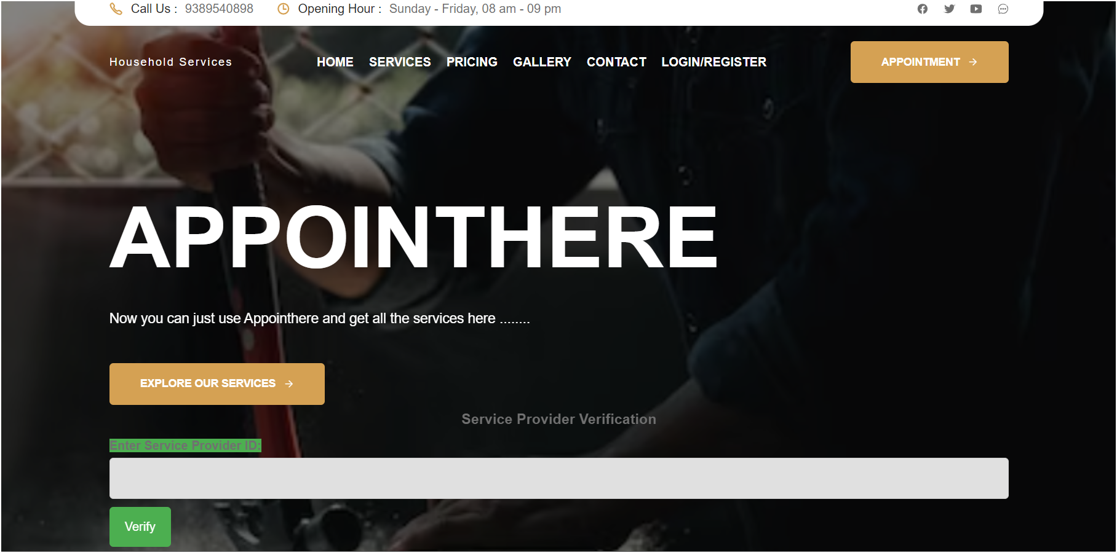

### 7.2 SNAPSHOTS OF DATABASE TABLE

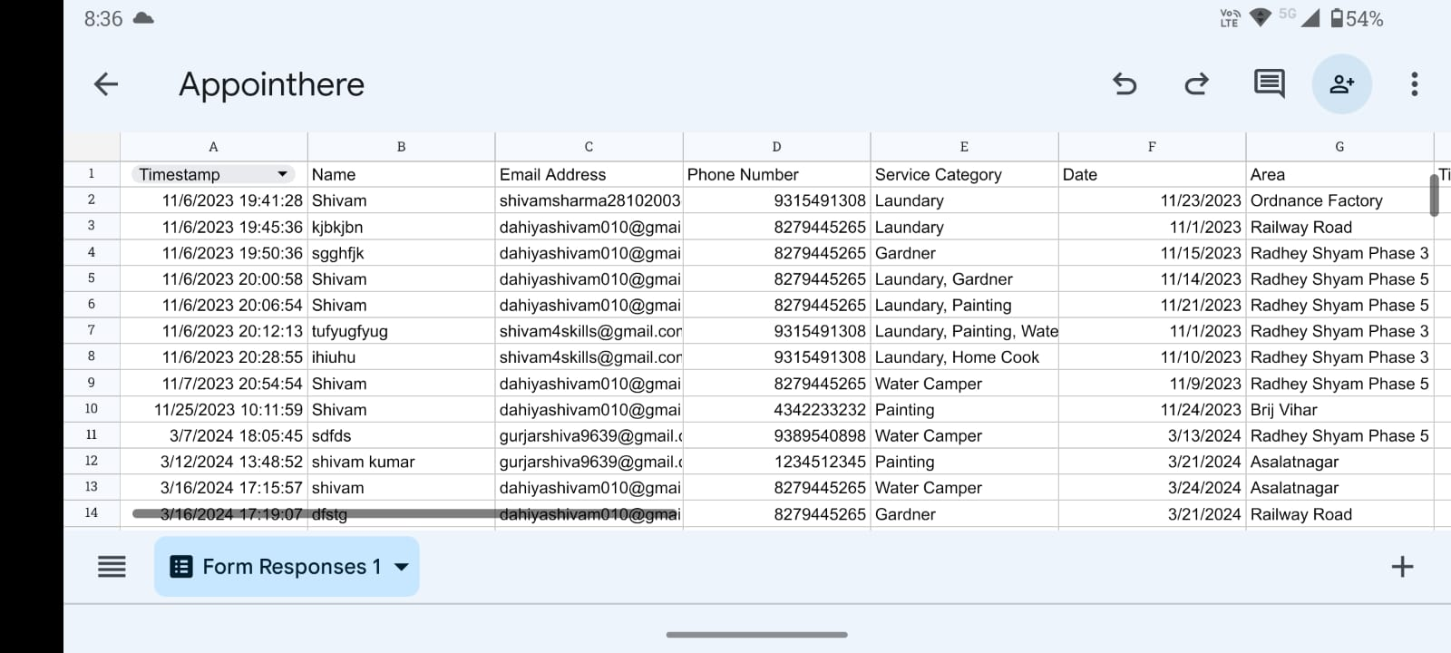

## CHAPTER 8: CONCLUSION AND REFERENCES

### CONCLUSION

In conclusion, the development of AppoinHere marks a significant milestone in addressing the modern-day challenges of balancing professional commitments with household responsibilities. Through meticulous planning, innovative design, and robust implementation, we have created a platform that revolutionizes the way individuals access and manage essential household services.

Our journey began with a recognition of the growing need for convenience and efficiency in everyday life. We understood the frustrations of navigating the complexities of finding reliable service providers amidst busy schedules and competing priorities. With this insight, we set out to create a solution that would simplify the process, bringing a wide range of services directly to users' doorsteps with just a few clicks.

Throughout the development process, we remained committed to our core values of user-centric design, reliability, and accessibility. We leveraged cutting-edge technologies and industry best practices to ensure that AppoinHere delivers an unparalleled user experience, from seamless booking and transparent pricing to secure transactions and timely service delivery.

As we reflect on our achievements, we are proud to see AppoinHere making a tangible difference in the lives of our users. Whether it's fixing a leaky faucet, cleaning a cluttered space, or tackling a home renovation project, our platform empowers individuals to reclaim their time and focus on what matters most.

Looking ahead, we are excited about the possibilities for growth and expansion. We envision AppoinHere becoming the go-to destination for all household service needs, serving communities far and wide with our commitment to excellence and innovation.

In closing, we extend our heartfelt gratitude to all who have contributed to this journey – our team members, partners, and most importantly, our users. Together, we have built more than just a platform; we have built a community dedicated to simplifying life's everyday challenges. As we continue to evolve and adapt to meet the changing needs of our users, we remain steadfast in our mission to make household services more accessible, reliable, and convenient for everyone.

REFERENCES :

[1] Shahrzad Shahriari, Mohammadreza Shahriari, Saeid gheiji. “ ECommerce And It Impactson Global Trend And Market”.International Journal of Research – Granthaalayah. Vol.3 (Iss.4): April, 2015. [2] L.RichardYe, Yue Jeff Zhang, Dat-DaoNguyen, James Chiu,“Fee-based online services: Exploring consumers’willingness to pay ”. Journal of International Technologyand Information Management. [3] Bo Zhang, Ruihan Yong, Meizi Li, Jianguo Pan, Jifeng Huanglaa, “ A Hybrid Trust Evaluation Framework for E-commerce in Online Social Network: ”. 2169-3536 (c) 2016 IEEE. Translations and content mining are permitted for academic research [4] Chenggang Zhen,Peng Cheng. “Construction of campus trading platform based on third-party online payment ” 2nd International Conference on Industrial and Information Systems,IEEE,2010 [5] Sujit Kumar Basak,Irene Govender.“Examining the Impact of Privacy, Security, and Trust on the TAM and TTF Models for Ecommerce Consumers: A Pilot Study”,IEEE, 2009 [6] CAl Yrnn-ping, WANG Yu-ying, “Simple Said about Online Payment Risks and Preventive Measure ”, China located International Conference on Infonnation Systems for Crisis Response and Management,IEEE,2010 [7] An Online System for Household Services N. M. Indravasan1 , Adarsh G2 , Shruthi C 3 , Shanthi K 4 , Dadapeer 5 BITM, Ballari